**Plasma Donor Application**

**Abstract:**

* This system is used if anyone needs a Plasma Donor. This system comprises of Admin and User where both can request for a Plasma.
* In this system there is something called an active user, which means the user is an Active member of the App and any sort of infection or disease he/she has recovered from.
* Both parties can Accept or Reject the request.
* The person who wants to donate his/her plasma needs to register in our application providing required information which are name, age, plasma group, phone number, and location, etc.
* Patients who need plasma can also fill the form to request the plasma. Patients can directly call the donor by taking his/her contact number from the application.
* User can also search based on location they are living in using their phone’s network to let them find and connect with people for plasma requirements.
* Just a single search allows anyone to reach maximum number of plasma donors in minimum possible time and that too within just 5kms from where the plasma is required.
* Also saves plasma donation history, to increase the possibility of saving lives.

**Novelty:**

Cloud communicating is an emerging technology that can be integrated with traditional health management used to provide better health services. Traditional healthcare systems mainly include personal and public healthcare services, teaching and research activities. Personal healthcare services are offered at hospitals, homes and different organizations. Public healthcare services involve guidelines for drugs, food and safety policies to maintain a healthy environment. Teaching and research activities are essential for prevention, detection, tracking and treatment of diseases. Healthcare information systems are designed today for the convenience of the user who obtains its bene fits. In many emergency situations there is an immediate, critical need for specific plasma. In addition to emergency requirements, advances in medicine have increased the need for plasma in many ongoing treatments and medical surgeries. To motivate people for plasma donation and to help patients receive plasma in emergency situations, we have designed an application to overcome all the problems which the current offline as well as online systems face. If in emergency a patient requires plasma, using this application we'll not just be able to contact Blood/Plasma Bank and Hospitals but can also seek help from individual registered Donors. In developing countries, especially like India, the plasma resource lacks in quantity which is a barrier to others life. The willingness of donor and the closeness of the donor to the place from where the call is coming are also accounted for in defining this algorithm. Based on the algorithm the most eligible donor is found out. From the server the call from the required person is routed to the eligible donor's number. We utilized the cloud computing service for keeping the application data available anywhere and anytime. The superior feature of our application is to use it as a volunteer plasma donor as well requester. Requester can broadcast the message along urgency sign of required plasma to the registered users and notification message will send to all the volunteer plasma donors.

# Feasibility Of Ideas:

**Admin:**

Admin can manage both donors & acceptors. He can add or remove any user from the system. Each member in a donor &

acceptor is given a user id and password, which identifies him uniquely. From admin module use can change donor details,

delete donor or change the password.

· Change Password

· Modify donor details

· Delete donor details

· Logout

**Login:**

To login in the system user has first register himself/herself. After successful Registration user can login into the system Plasma

Donor.

**Acceptors:**

This module helps user to find plasma group. When user click on find a plasma group system ask him to enter plasma group he wants to search. After entering the plasma group, system search for the availability of the plasma group and give him the list of the donors who has the same plasma group. Whenever a user wants to change password, he can select the change password option. Then system ask the user to enter old username and password then system check the credentials and change the password. Clicking on logout button user can log out from the system.

# Business Model:

The people who are in need of plasma can search in our site for getting the details of donors having the same plasma group and

within the same city or his current location. They can directly search a donor and can select a city name as well as the plasma

group which he needs. He then gets the details of the donors who exist within the city and the same plasma that he has selected. If no match was are found for the city and group selected by him, he gets a message ‘SORRY DONORS ARE NOT

AVAILABE WITH THE FOLLOWING PLASMA GROUP AND AREA’.

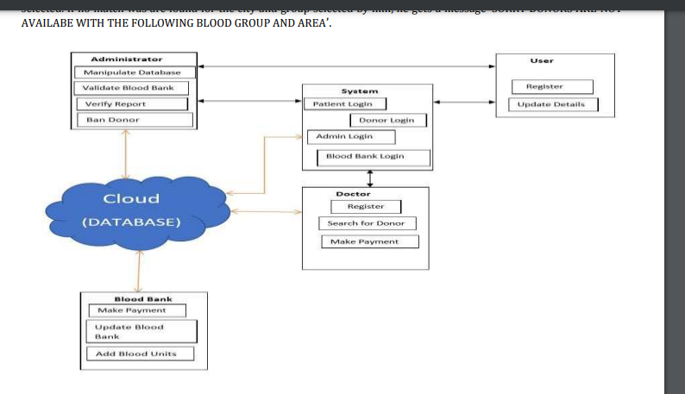

# Scalability:

The aim is to build a Lifesaver E-Plasma Donation App using Cloud with advanced features that will help to overcome the barrier between plasma bank, plasma donor and patient. To build an android application that will help people to get plasma in emergency situations like natural disasters using features like geo-tagging, SMS Gateway and payment gateway. To motivate people for plasma donation and to help patients receive plasma in emergency situations, we have designed an application to overcome all the problems which the current offline as well as online systems face. If in emergency a patient requires plasma, using this application we’ll not just be able to contact plasma Bank and Hospitals but can also seek help from individual registered Donors